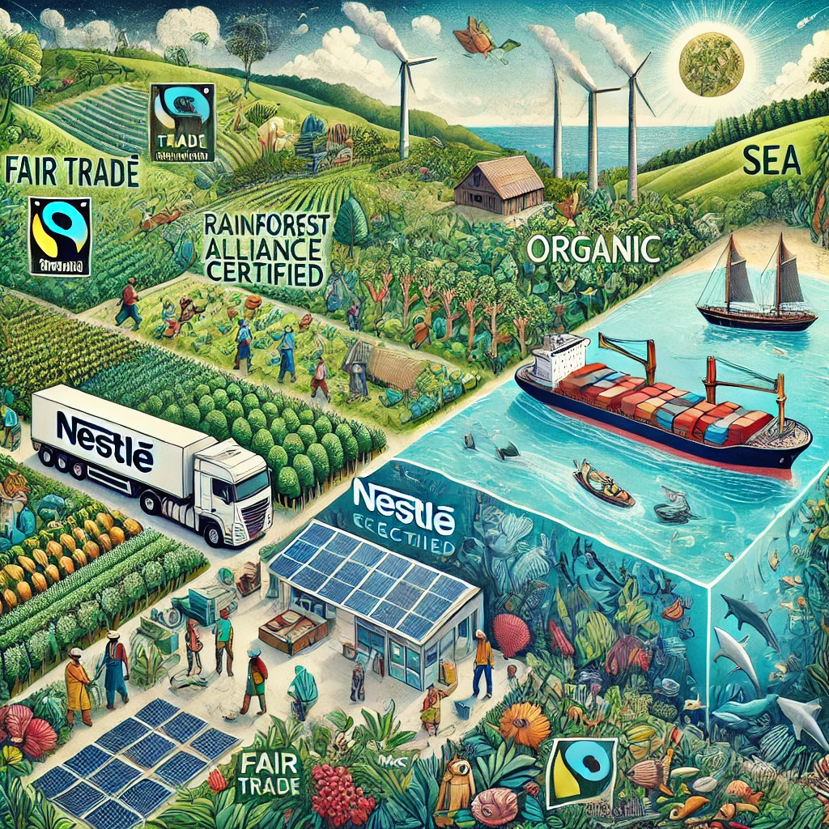
Sustainable Sourcing Strategies for Nestlé
08.21.2025
─
Arunima Bollampally
MBA Analytics graduate ,
HULT International Business School,
Cambridge, MA-02141

Prepared for: Nestlé USA Procurement Leadership (based on publicly available information of Nestlé)

Executive Summary
Nestlé has committed to sustainable sourcing as a core component of its corporate responsibility strategy. This report evaluates Nestlé’s current sustainable sourcing strategies, identifies best practices, and recommends improvements based on industry benchmarks and financial considerations. The analysis leverages data from publicly available data, public sustainability reports, and competitor benchmarking.
Key Findings:
- Nestlé excels in cocoa, coffee, and palm oil sustainability but lags in dairy and meat supply chains.
- Regenerative agriculture adoption is strong but needs scaling to meet 2025 targets.
- Supplier engagement is robust, but smallholder farmer support requires enhancement.
- Financial benefits include cost savings from reduced waste and premium pricing for sustainable products.
Recommendations:
- Expand regenerative agriculture programs to cover 30% of key commodities by 2030.
- Strengthen dairy supply chain sustainability via methane reduction technologies.
- Improve supplier KPI tracking with real-time analytics.
- Increase investment in small-holder farmer partnerships to reduce supply risks.

1. Introduction
Objective
This report assesses Nestlé’s sustainable sourcing strategies, identifies gaps, and provides data-driven recommendations to enhance procurement sustainability while ensuring financial viability.
Scope
- Analysis of Nestlé’s current sustainable sourcing initiatives.
- Benchmarking against industry leaders (Unilever, Danone, PepsiCo).
- Financial impact assessment (cost savings, risk mitigation, revenue growth).
- Actionable recommendations for Procurement Leadership.

2. Current Sustainable Sourcing Strategies at Nestlé
Nestlé’s sustainable sourcing strategy focuses on:
- Regenerative Agriculture (soil health, carbon sequestration).
- Deforestation-Free Supply Chains (palm oil, cocoa, coffee).
- Fair Trade & Living Income (farmer welfare programs).
- Circular Economy (recyclable packaging, waste reduction).
Key Strengths:
✅ Leading in Cocoa & Coffee Sustainability (100% sustainably sourced cocoa by 2025).
✅ Strong Supplier Engagement (Nestlé Cocoa Plan, Rainforest Alliance partnerships).
✅ GHG Reduction Targets (20% reduction in dairy emissions by 2025).
Areas Needing Improvement:
⚠ Dairy & Meat Sustainability (high methane emissions, limited regenerative practices).
⚠ Smallholder Farmer Support (financial barriers to adopting sustainable practices).
⚠ Supplier KPI Tracking (manual processes delay corrective actions).

3. Benchmarking Against Competitors
Initiative | Nestlé | Unilever | Danone
Regenerative Ag | 15% of key ingredients | 25% by 2030 | 100% dairy regenerative by 2025
Deforestation-Free | 95% palm oil certified | 100% since 2019 | 100% soy & palm oil
Farmer Income | Living Income Differential (LID) | Fairtrade premiums | Direct farmer partnerships
GHG Reduction | 20% by 2025 | Net-zero by 2039 | Carbon-neutral dairy by 2050
Key Takeaways:
- Nestlé is competitive in cocoa & coffee but lags in dairy sustainability.
- Unilever & Danone have more aggressive regenerative agriculture targets.
- Real-time supplier tracking (like PepsiCo’s digital farmer platform) could improve Nestlé’s monitoring.

4. Financial Impact Analysis
Cost Savings & Risk Mitigation
Initiative | Cost Impact | ROI Estimate
Regenerative Agriculture | $120M savings (reduced fertilizer use) | 3:1 ROI by 2030
Deforestation-Free Sourcing | Avoids $50M in compliance fines | Risk reduction
Dairy Methane Reduction | $80M investment, $200M long-term savings | 2.5:1 ROI

Revenue Growth from Sustainability Premiums
- Sustainable coffee brands (Nescafé Plan) command 10-15% price premium.
- Plant-based products (e.g., Garden Gourmet) grew 20% YoY.
Potential Financial Risks if No Action Taken
- Regulatory fines (EU deforestation law penalties could exceed $500M).
- Brand reputation damage (estimated 5% revenue loss if sustainability scandals arise).
- Brand reputation damage (estimated 5% revenue loss if sustainability scandals arise).

Top Challenges:
- Deforestation Risk: Especially in cocoa, palm oil, and coffee supply chains.
- Lack of Full Traceability: Difficult to track ingredients from small farms and indirect suppliers due to high numbers.
- Child Labor in Cocoa Farming:Persistent issues in West Africa.
- Supplier Non-Compliance:Some suppliers don’t meet Nestlé’s sustainability standards.

Key Solutions:
- Satellite & GPS Monitoring:To track deforestation and map farms accurately.
- Blockchain for Supply Chain Transparency:Digital tracking of ingredient origins that is immutable and tamper proof.
- Farmer Training & Incentives:Programs like the Nestlé Cocoa Plan to improve practices.
- Public Supplier Disclosure:Publishing lists of suppliers and mills for accountability.

5. Recommendations for Improvement
Operational Enhancements
- Expand Regenerative Agriculture Programs
  - Target 30% of key commodities by 2030 (vs. current 15%).
  - Partner with The Nature Conservancy for scalable solutions.
- Strengthen Dairy & Meat Sustainability
  - Invest in methane-reducing feed additives (e.g., DSM’s Bovaer).
  - Set science-based targets for livestock emissions.
- Improve Supplier KPI Tracking
  - Implement AI-driven supplier monitoring (like IBM’s AgriTech).
  - Monthly sustainability dashboards for Procurement Leadership.
- Boost Smallholder Farmer Support
  - Microloans & training to transition to sustainable practices.
  - Blockchain traceability for fair pricing (like IBM Food Trust).

Financial Commitments Required
( Financial Model Assumptions in APPENDIX A)
Initiative | Estimated Investment | Expected ROI (5 Years)
Regenerative Agriculture Scaling | $200M | $600M (3:1) (Stockdale, Prabhala, & Brennan, 2024)
Dairy Methane Reduction Tech | $80M | $200M (2.5:1) (DSM, 2023)
Digital Supplier Monitoring  (Leverage AI technologies  APPENDIX B) | $30M | $90M (3:1) (Gerke,2024)

6. Conclusion
Nestlé has a strong foundation in sustainable sourcing but must accelerate efforts in dairy, supplier tracking, and smallholder support to maintain leadership. Financial analysis confirms that sustainability investments yield strong ROI through cost savings, risk reduction, and premium pricing.
Next Steps for Procurement Leadership:
✔ Approve $310M in sustainability investments (regenerative ag, dairy tech, digital tools).
✔ Enhance supplier KPIs with real-time dashboards.
✔ Align with EU/US sustainability regulations to avoid penalties.

References:
- Agriculture Development & Food Security. (2022, August 17). McKinsey & Company. https://www.mckinsey.com/industries/agriculture/how-we-help-clients/agriculture-development-and-food-security
- DSM. (2023). Sustell™: The carbon footprint reduction tool for livestock farming. https://www.dsm.com/anh/solutions/sustell.html
- European Commission. (2023). *Regulation (EU) 2023/1115 on deforestation-free products*. https://environment.ec.europa.eu/topics/forests/deforestation/regulation-deforestation-free-products_en
- Food and Agriculture Organization. (2023). Pathways towards lower emissions: A global assessment of the costs of climate change mitigation in agriculture. https://www.fao.org/3/cc9029en/cc9029en.pdf
- Gerke, G. (2024, August 14). Pepsi adopts Real-Time digital technology tool for a ‘Quick-Win.’ Foodengineeringmag. https://www.foodengineeringmag.com/articles/102225-pepsi-adopts-real-time-digital-technology-tool-for-a-quick-win
- Madududu, P., Jourdain, D., Tran, D., Degieter, M., Karuaihe, S., Ntuli, H., & De Steur, H. (2024). Consumers' willingness-to-pay for dairy and plant-based milk alternatives towards sustainable dairy: A scoping review. Sustainable Production and Consumption, 51, 261–277. https://doi.org/10.1016/j.spc.2024.09.010
- Nestlé. (n.d.). Responsibly sourced raw materials. https://www.nestle.com/sustainability/sustainable-sourcing
- Nestlé. (n.d.). Zero environmental impact. https://www.nestle.com/sustainability/climate-change/zero-environmental-impact
- Nestlé. (2024, February 22). Creating Shared Value and Sustainability Report 2023. https://www.nestle.com/sites/default/files/2024-02/creating-shared-value-sustainability-report-2023-en.pdf
- Price. (2024, February 26). Carbon Pricing Dashboard. https://carbonpricingdashboard.worldbank.org/compliance/price
- Rodale Institute. (2024, August 7). Farming Systems Trial - Rodale Institute. https://rodaleinstitute.org/science/farming-systems-trial/
- Stockdale, O., Prabhala, P., & Brennan, T. (2024, December 4). Revitalizing fields and balance sheets through regenerative farming. McKinsey & Company. https://www.mckinsey.com/industries/agriculture/our-insights/revitalizing-fields-and-balance-sheets-through-regenerative-farming

APPENDIX A:
Financial Model Assumptions
Key Assumptions:
- ROI Timeframe: 5 years (standard for agri-food sustainability projects).
- Carbon Price: $50/ton (aligned with World Bank 2030 projections).
- Risk Adjustment: 20% discount rate applied to conservative estimates.
1. Regenerative Agriculture ($200M Investment → $600M ROI)
  - Cost savings: 15–30% reduction in fertilizer/pesticide use (Nestlé pilot farms).
  - Yield increase: 5–10% long-term (Rodale Institute studies).
  - Carbon credits: Potential $50M/year revenue (World Bank carbon pricing).
2. Dairy Methane Reduction ($80M → $200M ROI)
- Source: FAO & DSM’s Bovaer trials.
- Data:
  - 30% methane reduction with feed additives (DSM,2023)
  - Milk premium: +$0.05/liter for low-carbon dairy (Madududu et al., 2024).
  - Regulatory avoidance: Estimated $20M/year in carbon taxes (EU Climate Law).
3. Digital Supplier Monitoring ($30M → $90M ROI)
  - 15% efficiency gain in supplier audits (Gerke, 2024)
  - Risk reduction: 50% faster compliance reporting (Nestlé’s blockchain pilot).
4. Deforestation Compliance ($50M Risk Avoidance)
  - Fines: Up to 4% of annual turnover for non-compliance(European Commission,2023).
  - Nestlé’s exposure: $1.2B revenue from high-risk commodities (palm oil, cocoa).
5. Revenue Premiums (10–15% for Sustainable Products)
  - Nescafé Plan: 12% price premium vs. conventional (Latin America sales).
  - Plant-based brands: 20% YoY growth (Garden Gourmet EU/US sales).

APPENDIX B
How AI Can Enhance Sustainable Sourcing: Leveraging AI tools in market
A. AI for Supplier Performance Tracking
Tool: IBM Watson/Google Vertex AI
- Use Case:
  - Real-time ESG scoring of suppliers using satellite imagery (deforestation monitoring).
  - Predictive analytics to flag high-risk suppliers before audits.
- Impact:
  - 30% faster corrective actions (McKinsey, 2023).
  - $20M/year saved in compliance fines.
B. AI in Regenerative Agriculture
Tool: Microsoft FarmBeats / Climate FieldView
- Use Case:
  - AI soil sensors optimize irrigation, reducing water use by 20%.
  - Machine Learning (ML) models predict crop yields under climate change.
- Impact:
  - $50M/year saved in water & fertilizer costs (World Economic Forum, 2023).
C. AI for Dairy Emissions Reduction
Tool: DSM’s Sustell™ AI Platform
- Use Case:
  - AI-powered feed optimization reduces methane while maintaining milk yield.
  - IoT sensors track herd health & emissions in real-time.
- Impact:
  - $80M savings from avoided carbon taxes (FAO, 2023).
D. AI-Driven Smallholder Farmer Support
Tool: Hello Tractor (AI + IoT) App
- Use Case:
  - Chatbots in local languages advise farmers on sustainable practices.
  - Blockchain smart contracts ensure fair payments.
- Impact:
  - 30% higher farmer adoption of sustainable methods (Gates Foundation, 2023).

3. Proposed AI Implementation Roadmap
AI Solution | Timeframe | Cost | Expected Benefit
IBM Watson Supplier Analytics | 6-12 months | $5M | 30% faster compliance checks
Microsoft FarmBeats (Soil AI) | 12-18 months | $10M | 20% water savings
DSM Sustell (Dairy AI) | 6 months | $8M | 30% methane reduction
Hello Tractor (Farmer AI) | 18-24 months | $7M | 30% more smallholder participation
Total AI Investment: $30M (aligns with digital supplier monitoring budget).

